How To Make SharePoint Stop Asking for your Login In IE

1. Go to the tools menu in IE and Select Internet options.

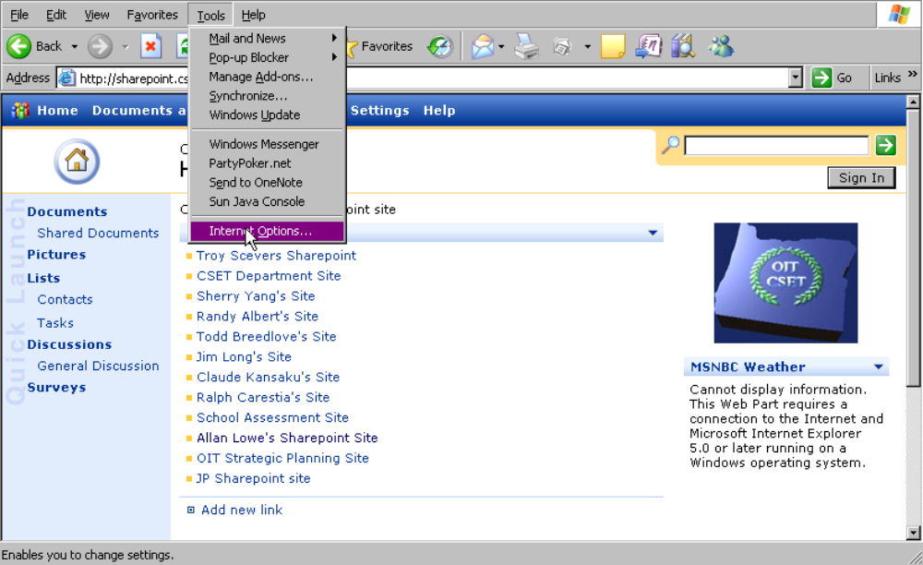

2. Select the Security Tab.
3. Then Select Local intranet
4. Then Click on Sites

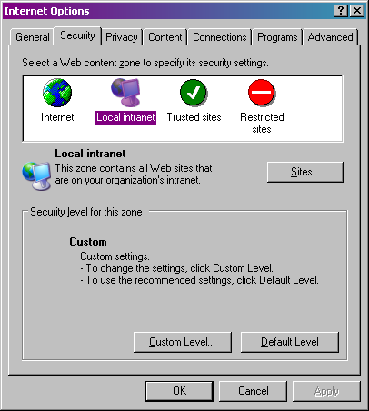

5. This should bring up the following screen. Now click on advanced.
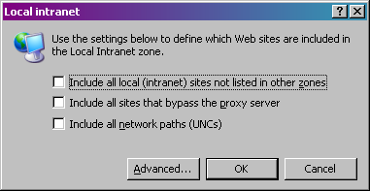

6. Now type in http://sharepoint.cset.oit.edu and click the add button. Then click OK until you are back at IE screen. IE should no longer prompt you for your username when downloading documents…

